Full Name | Nanubolu Sai Surya Kiran
Batch | MS FSD DEC 2021 Cohort 1
Project Name | Learners Academy
Project Submission Date | 09-04-2022

Source Code
Login.java
package myPackage;

import java.io.IOException;

import javax.servlet.ServletException;
import javax.servlet.annotation.WebServlet;
import javax.servlet.http.HttpServlet;
import javax.servlet.http.HttpServletRequest;
import javax.servlet.http.HttpServletResponse;
import javax.servlet.http.HttpSession;

@WebServlet("/Login")
public class Login extends HttpServlet {

protected void doPost(HttpServletRequest request, HttpServletResponse response) throws ServletException, IOException
{
String username = request.getParameter("username");
String password = request.getParameter("password");

if(username.equals("username") && password.equals("password"))
{
HttpSession session = request.getSession();
session.setAttribute("username", username);
response.sendRedirect("Admin.jsp");
}
else
{
response.sendRedirect("Login.jsp");
}
}
}

Login.jsp
<%@ page language="java" contentType="text/html; charset=ISO-8859-1"
pageEncoding="ISO-8859-1"%>
<!DOCTYPE html>
<html>
<head>
<meta http-equiv="Content-Type" content="text/html; charset=ISO-8859-1">
<title>Welcome to Learner's Academy</title>
</head>
<body>
<form action="Login" align="center" method="post">
<h1>Welcome to Learner's Academy</h1>

<br></br>
Enter username : <input type="text" name="username"> <br>
<br> Enter password : <input type="password" name="password"> <br>
<br> <input type="submit" value ="Sign In">
</form>
</body>
</html>

Admin.jsp
<%@ page language="java" contentType="text/html; charset=ISO-8859-1"
pageEncoding="ISO-8859-1"%>
<!DOCTYPE html>
<html>
<head>
<meta charset="ISO-8859-1">
<title>Admin</title>
</head>
<body align="center">

<%
response.setHeader("Cache-Control","no-cache, no-store, must-revalidate"); //It will not store the cache. It prevents back button issue.

if(session.getAttribute("username")==null)
{
response.sendRedirect("Login.jsp");
}
%>

<h1>Administrative Portal</h1>
<table align="center">
<th>
<a href="Classes.jsp">Classes</a><br>
<a href="Students.jsp">Students</a><br>
<a href="Subjects.jsp">Subjects</a><br>
<a href="Faculty.jsp">Faculty</a><br>
<a href="Schedule.jsp">Schedule</a><br>
</th>
</table>
<br></br>

<form action="Logout" method="post">
<input type="submit" value="Logout">
</form>

</body>
</html>
Classes.jsp
<%@ page language="java" contentType="text/html; charset=ISO-8859-1"
pageEncoding="ISO-8859-1"%>

<%@ taglib prefix="sql" uri="http://java.sun.com/jsp/jstl/sql" %>
<%@ taglib prefix="c" uri="http://java.sun.com/jsp/jstl/core" %>

<!DOCTYPE html>
<html>
<head>
<meta charset="ISO-8859-1">
<title>Classroom Details</title>
</head>
<body align="Center">
<%
response.setHeader("Cache-Control","no-cache, no-store, must-revalidate"); //It will not store the cache. It prevents back button issue.

if(session.getAttribute("username")==null)
{
response.sendRedirect("Login.jsp");
}
%>

<a href="Admin.jsp">Administrative</a>
<a href="Students.jsp">Students</a>
<a href="Subjects.jsp">Subjects</a>
<a href="Faculty.jsp">Faculty</a>
<a href="Schedule.jsp">Schedule</a><br>
<h3>Class Rooms in Learner's Academy</h3>
<sql:setDataSource var="db" driver="com.mysql.jdbc.Driver" url="jdbc:mysql://localhost:3306/KiranDB" user="root" password="Kiran@2402"/>
<sql:query var="rs" dataSource="${db}"> select * from ClassRooms </sql:query>

<table align="center" border = "1.5" width = "auto">

<th>Room No</th>
<th>Room Name</th>

<c:forEach items="${rs.rows}" var="ClassRooms">

<tr>
<td><c:out value="${ClassRooms.Room_No}"></c:out></td>
<td><c:out value="${ClassRooms.ClassRoomName}"></c:out></td>
</tr>

</c:forEach>
</table>
<br></br>
<form action="Logout" method="post">
<input type="submit" value="Logout">
</form>
</body>
</html>

Students.jsp
<%@ page language="java" contentType="text/html; charset=ISO-8859-1"
pageEncoding="ISO-8859-1"%>

<%@ taglib prefix="sql" uri="http://java.sun.com/jsp/jstl/sql" %>
<%@ taglib prefix="c" uri="http://java.sun.com/jsp/jstl/core" %>

<!DOCTYPE html>
<html>
<head>
<meta charset="ISO-8859-1">
<title>Students Details</title>
</head>
<body align="Center">
<%
response.setHeader("Cache-Control","no-cache, no-store, must-revalidate"); //It will not store the cache. It prevents back button issue.

if(session.getAttribute("username")==null)
{
response.sendRedirect("Login.jsp");
}
%>

<a href="Admin.jsp">Administrative</a>
<a href="Classes.jsp">Class Rooms</a>
<a href="Subjects.jsp">Subjects</a>
<a href="Faculty.jsp">Faculty</a>
<a href="Schedule.jsp">Schedule</a><br>
<h3>Students List</h3>
<sql:setDataSource var="db" driver="com.mysql.jdbc.Driver" url="jdbc:mysql://localhost:3306/KiranDB" user="root" password="Kiran@2402"/>
<sql:query var="rs" dataSource="${db}"> select * from Students </sql:query>

<table align="center" border = "1.5" width = "auto">

<th>Roll No</th>
<th>First Name</th>
<th>Last Name</th>
<th>Gender</th>
<th>Age</th>
<th>Course</th>
<c:forEach items="${rs.rows}" var="Students">

<tr>
<td><c:out value="${Students.Roll_No}"></c:out></td>
<td><c:out value="${Students.First_Name}"></c:out></td>
<td><c:out value="${Students.Last_Name}"></c:out> </td>
<td><c:out value="${Students.Gender}"></c:out></td>
<td><c:out value="${Students.Age}"></c:out></td>
<td><c:out value="${Students.Course}"></c:out></td>
</tr>

</c:forEach>
</table>
<br></br>
<form action="Logout" method="post">
<input type="submit" value="Logout">
</form>
</body>
</html>
Faculty.jsp
<%@ page language="java" contentType="text/html; charset=ISO-8859-1"
pageEncoding="ISO-8859-1"%>

<%@ taglib prefix="sql" uri="http://java.sun.com/jsp/jstl/sql" %>
<%@ taglib prefix="c" uri="http://java.sun.com/jsp/jstl/core" %>

<!DOCTYPE html>
<html>
<head>
<meta charset="ISO-8859-1">
<title>Faculty Details</title>
</head>
<body align="center">

<%
response.setHeader("Cache-Control","no-cache, no-store, must-revalidate"); //It will not store the cache. It prevents back button issue.

if(session.getAttribute("username")==null)
{
response.sendRedirect("Login.jsp");
}
%>

<a href="Admin.jsp">Administrative</a>
<a href="Classes.jsp">Class Rooms</a>
<a href="Students.jsp">Students</a>
<a href="Subjects.jsp">Subjects</a>
<a href="Schedule.jsp">Schedule</a><br>
<h3>Faculty Details</h3>
<sql:setDataSource var="db" driver="com.mysql.jdbc.Driver" url="jdbc:mysql://localhost:3306/KiranDB" user="root" password="Kiran@2402"/>
<sql:query var="rs" dataSource="${db}"> select * from Faculty </sql:query>

<table align="center" border = "1.5" width = "auto">

<th>Regd_Id</th>
<th>First Name</th>
<th>Last Name</th>
<th>Age</th>
<th>Gender</th>
<th>Subject</th>
<th>Salary</th>
<c:forEach items="${rs.rows}" var="Faculty">

<tr>
<td><c:out value="${Faculty.Regd_Id}"></c:out></td>
<td><c:out value="${Faculty.First_Name}"></c:out></td>
<td><c:out value="${Faculty.Last_Name}"></c:out> </td>
<td><c:out value="${Faculty.Age}"></c:out></td>
<td><c:out value="${Faculty.Gender}"></c:out></td>
<td><c:out value="${Faculty.Subject}"></c:out></td>
<td><c:out value="${Faculty.Salary}"></c:out></td>

</tr>

</c:forEach>
</table>
<br></br>
<form action="Logout" method="post">
<input type="submit" value="Logout">
</form>

</body>
</html>
Subjects.jsp
<%@ page language="java" contentType="text/html; charset=ISO-8859-1"
pageEncoding="ISO-8859-1"%>

<%@ taglib prefix="sql" uri="http://java.sun.com/jsp/jstl/sql" %>
<%@ taglib prefix="c" uri="http://java.sun.com/jsp/jstl/core" %>

<!DOCTYPE html>
<html>
<head>
<meta charset="ISO-8859-1">
<title>Subject Details</title>
</head>
<body align="center">
<%
response.setHeader("Cache-Control","no-cache, no-store, must-revalidate"); //It will not store the cache. It prevents back button issue.

if(session.getAttribute("username")==null)
{
response.sendRedirect("Login.jsp");
}
%>

<a href="Admin.jsp">Administrative</a>
<a href="Classes.jsp">Classes</a>
<a href="Students.jsp">Students</a>
<a href="Faculty.jsp">Faculty</a>
<a href="Schedule.jsp">Schedule</a><br>
<h3>Subject Details</h3>
<sql:setDataSource var="db" driver="com.mysql.jdbc.Driver" url="jdbc:mysql://localhost:3306/KiranDB" user="root" password="Kiran@2402"/>

<sql:query var="rs" dataSource="${db}"> select * from Subjects </sql:query>

<table align="center" border = "1.5" width = "auto">

<th>Subject Code</th>
<th>Subject Name</th>

<c:forEach items="${rs.rows}" var="Subjects">

<tr>
<td><c:out value="${Subjects.Subject_Code}"></c:out></td>
<td><c:out value="${Subjects.Subject_Name}"></c:out></td>

</tr>

</c:forEach>
</table>
<br></br>
<form action="Logout" method="post">
<input type="submit" value="Logout">
</form>
</body>
</html>
Schedule.jsp
<%@ page language="java" contentType="text/html; charset=ISO-8859-1"
pageEncoding="ISO-8859-1"%>

<%@ taglib prefix="sql" uri="http://java.sun.com/jsp/jstl/sql" %>
<%@ taglib prefix="c" uri="http://java.sun.com/jsp/jstl/core" %>

<!DOCTYPE html>
<html>
<head>
<meta charset="ISO-8859-1">
<title>Schedule</title>
</head>
<body align="center">
<%
response.setHeader("Cache-Control","no-cache, no-store, must-revalidate"); //It will not store the cache. It prevents back button issue.

if(session.getAttribute("username")==null)
{
response.sendRedirect("Login.jsp");
}
%>

<a href="Admin.jsp">Administrative</a>
<a href="Classes.jsp">Classes</a>
<a href="Students.jsp">Students</a>
<a href="Faculty.jsp">Faculty</a>
<a href="Subjects.jsp">Students</a><br>
<h3>Subject Details</h3>
<sql:setDataSource var="db" driver="com.mysql.jdbc.Driver" url="jdbc:mysql://localhost:3306/KiranDB" user="root" password="Kiran@2402" />

<sql:query var="rs" dataSource="${db}"> select * from Schedule </sql:query>

<table align="center" border = "1.5" width = "auto">

<th>Room No</th>
<th>Room Name</th>
<th>Faculty</th>
<th>Subject</th>
<th>Student</th>
<th>Time</th>

<c:forEach items="${rs.rows}" var="Schedule">

<tr>
<td><c:out value="${Schedule.Room_No}"></c:out></td>
<td><c:out value="${Schedule.Room_Name}"></c:out></td>
<td><c:out value="${Schedule.Faculty}"></c:out></td>
<td><c:out value="${Schedule.Subject}"></c:out></td>
<td><c:out value="${Schedule.Student}"></c:out></td>
<td><c:out value="${Schedule.Time}"></c:out></td>

</tr>

</c:forEach>
</table>
<br></br>
<form action="Logout" method="post">
<input type="submit" value="Logout">
</form>
</body>
</html>
Logout.Java
package myPackage;

import java.io.IOException;
import javax.servlet.ServletException;
import javax.servlet.annotation.WebServlet;
import javax.servlet.http.HttpServlet;
import javax.servlet.http.HttpServletRequest;
import javax.servlet.http.HttpServletResponse;
import javax.servlet.http.HttpSession;

/**
* Servlet implementation class Logout
*/
@WebServlet("/Logout")
public class Logout extends HttpServlet {

protected void doPost(HttpServletRequest request, HttpServletResponse response) throws ServletException, IOException {
HttpSession session = request.getSession();
session.removeAttribute("username");
session.invalidate();
response.sendRedirect("Login.jsp");
}
}

Screen Shots
Login Page
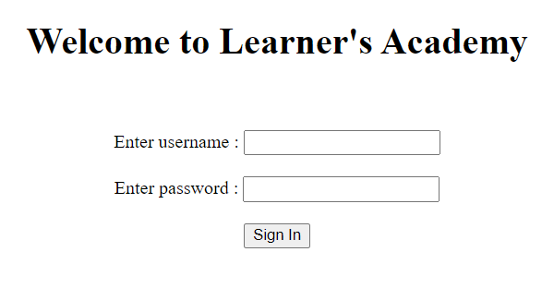
Logging In
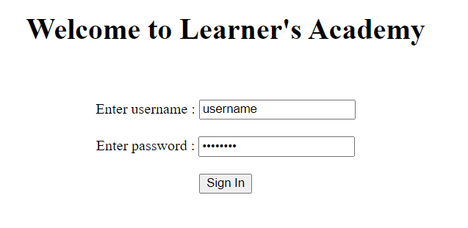
Admin Page
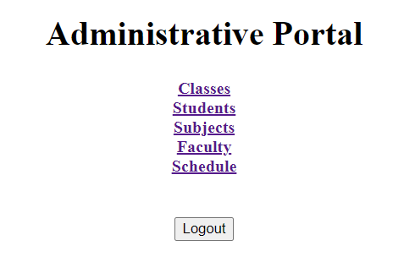

Class Rooms Master List
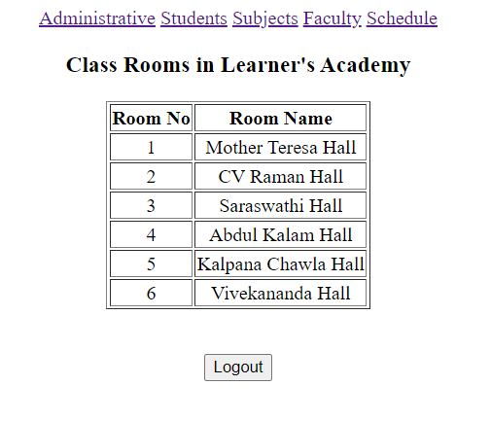

Students Master List
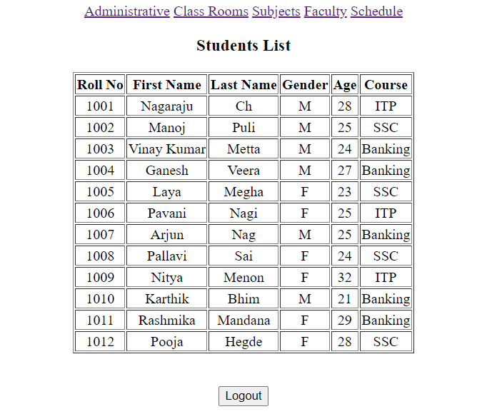

Subjects Master List
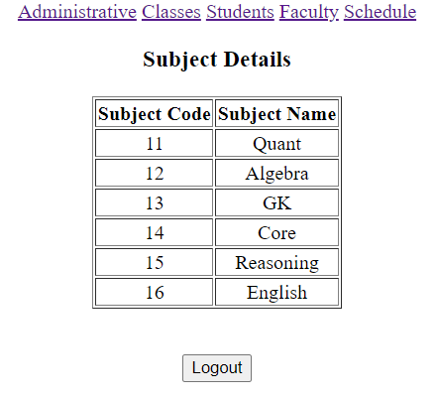
Faculty Master File
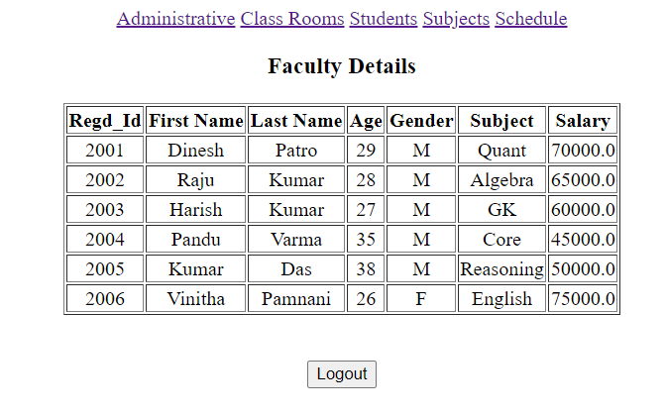

Schedule
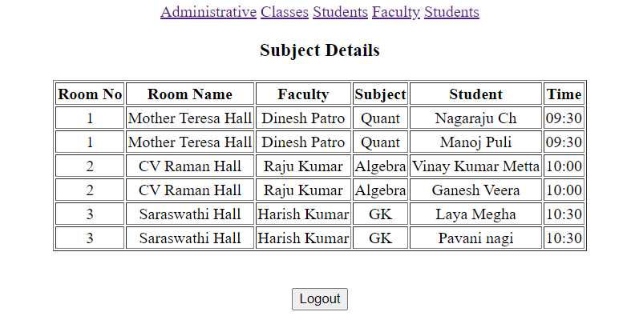

Flow Diagram
